**Steps To Change address of Soil sensors(NESA_SM.2-C)**

1. Install Modbus Poll
2. Download and install drive apps

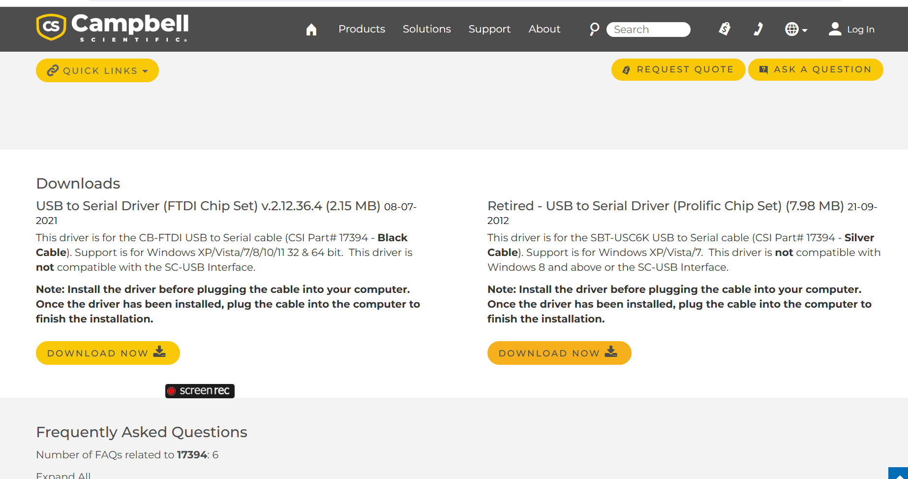

In second file open Driver for Win7 32bits

1. Wiring

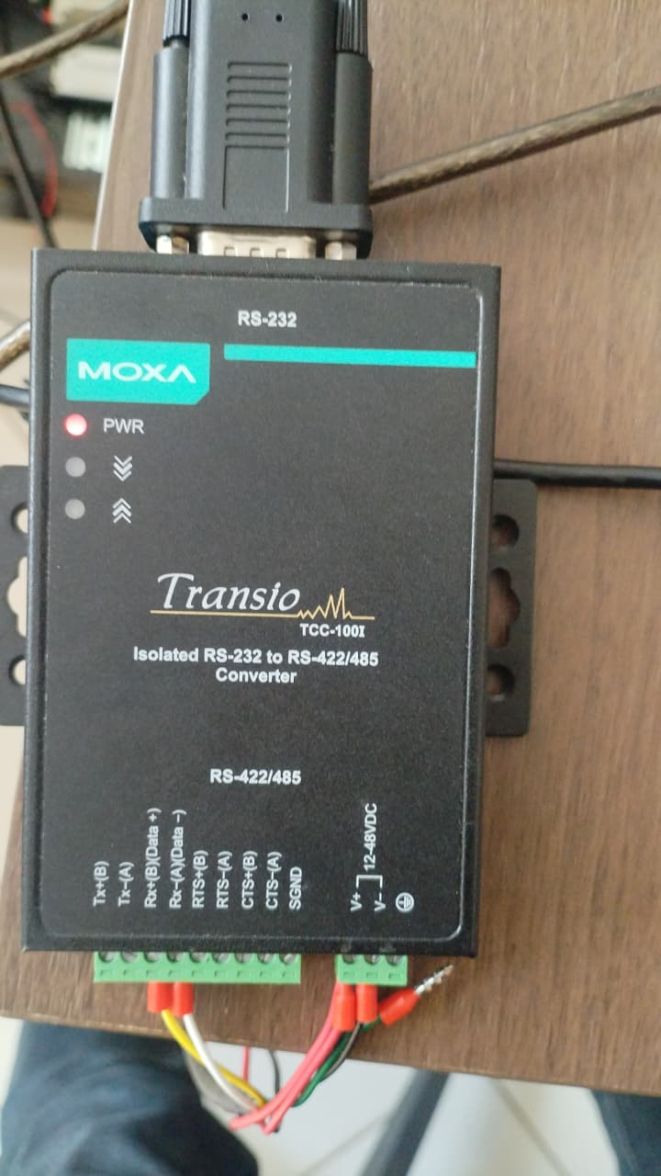

NB: All DIP switches (1 to 3) must be off.

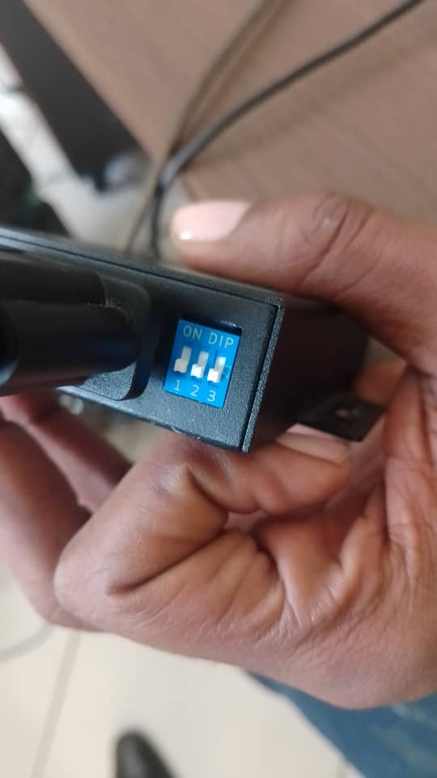

* Rx+(B)Data+: Yellow
* Rx-(A) Data-: White
* Red and Power from battery to V+
* Black and ground of battery to V-
* Green to SGND

1. Run Modbus Poll
2. Click connect then ,register later,ok.
3. Configure as shown below( COM port may vary)

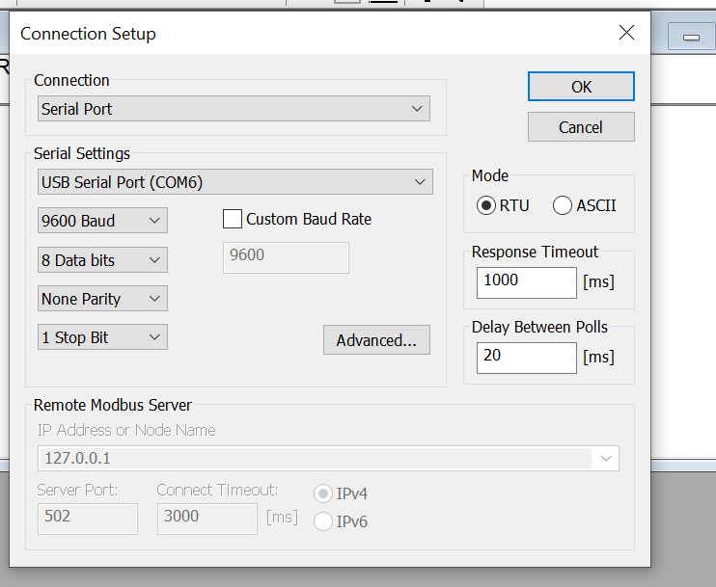

1. To Change address

* Go to function
* Select single register
* Current ID(filled automatically)
* Second field is register for slave ID(always 512)
* Last field is for new slave ID
* Send

1. Restating the Sensor

* Disconnect the power connector

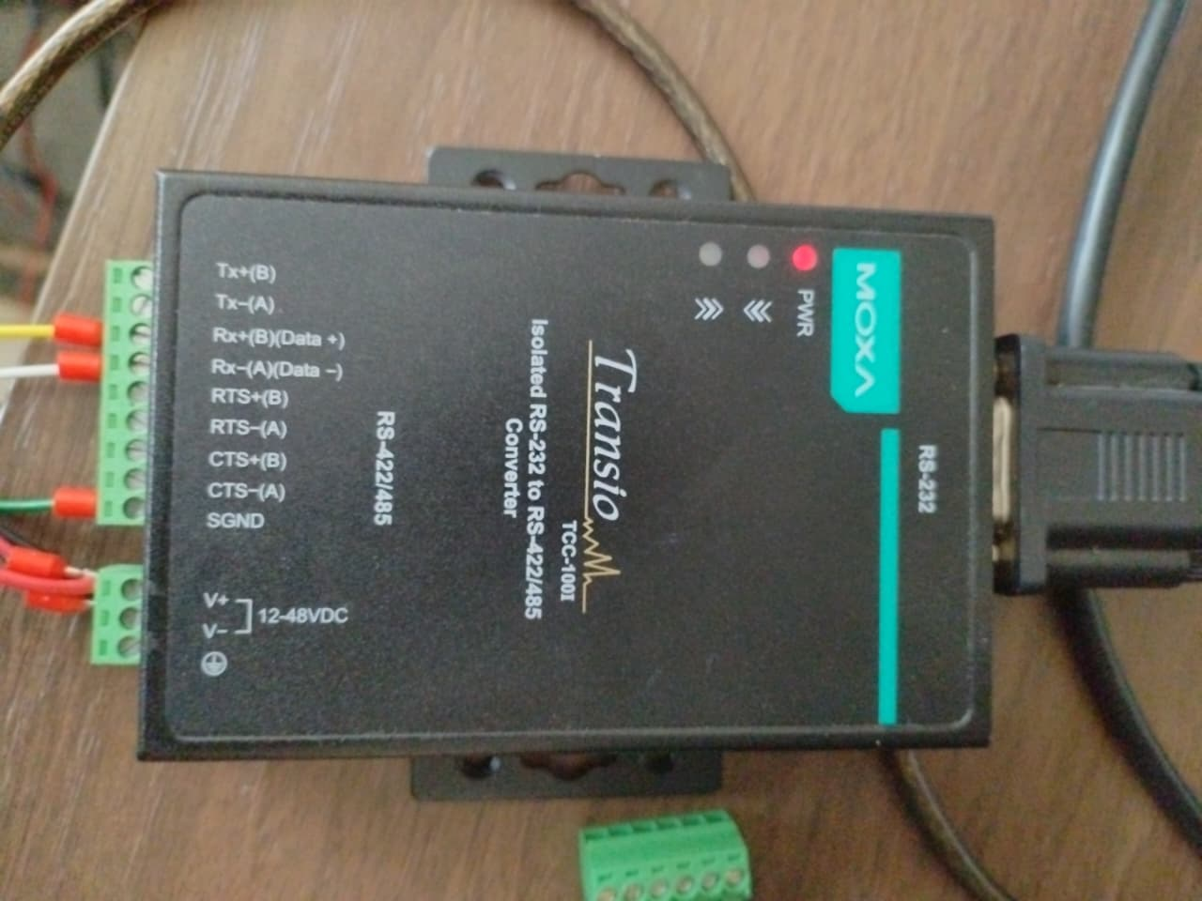

* Rx+(B)Data+: Yellow
* Rx-(A) Data-: White
* Exchange/swap green wire to the black one
* Exchange/swap again green wire to the black one

1. Check the readings on new Slave ID

* Go to set up
* Select set slave ID for all, then put new slave ID

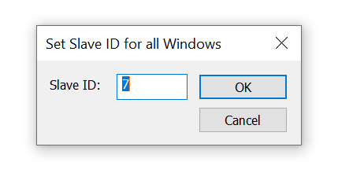

1. Readings

0: Soil temperature

1: Moisture content

2: Conductivity

